Computer Networks Laboratory

UE20CS255

|  |  |  |
| --- | --- | --- |
| Name: Naman Choudhary | SRN: PES2UG20CS209 | Section: D |

## Week 4

Understanding Persistent and Non-persistent HTTP Connections

## Objective:

To understand persistent and non-persistent HTTP connections and corresponding performance impact. Create a web page with N (e.g. 10) embedded images. Each image should be of minimum 2MB size. Configure your browser (Firefox ESR) with following settings (each setting requires repeat of experiment)

* Non persistent connection
* 2 persistent connections
* 4 persistent connections
* 6 persistent connections
* 8 persistent connections
* 10 persistent connections.

## Observation:

Note down the time taken to display the entire page in each of the settings. Ensure that (cache is cleared before starting the web request). Explain the response time differences. What is the optimal number of persistent connections for best performance? Explain your answer

## Configuration

Client:

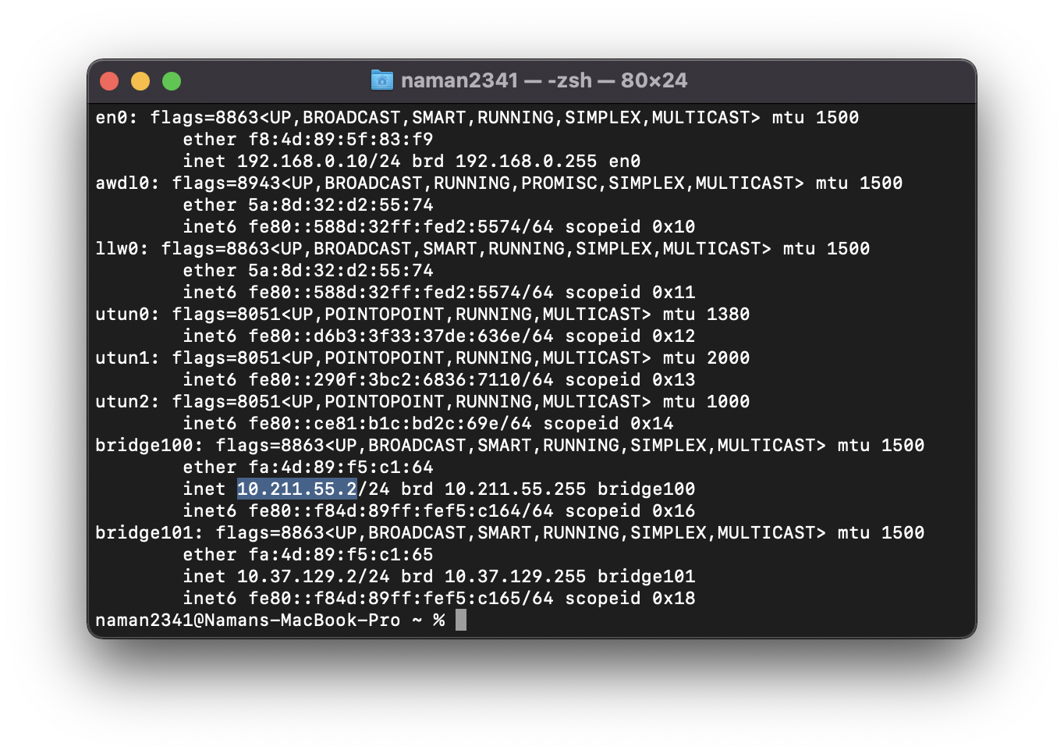

Server:

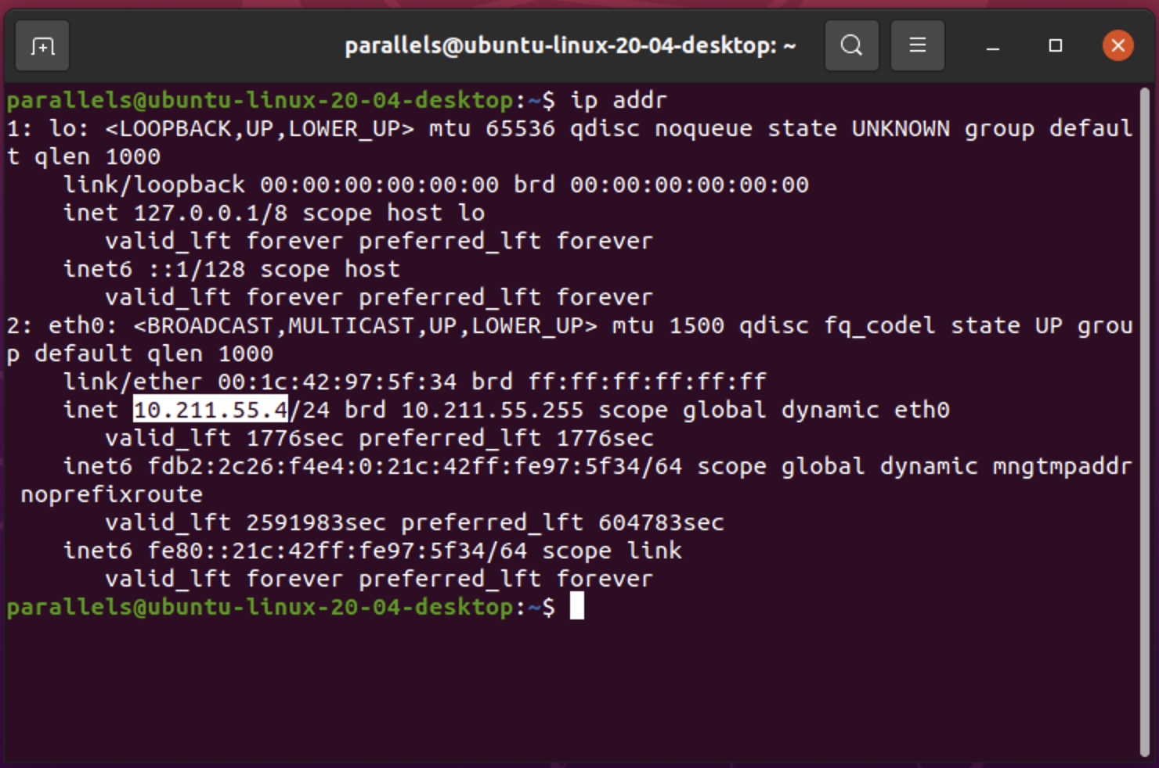

Server Running: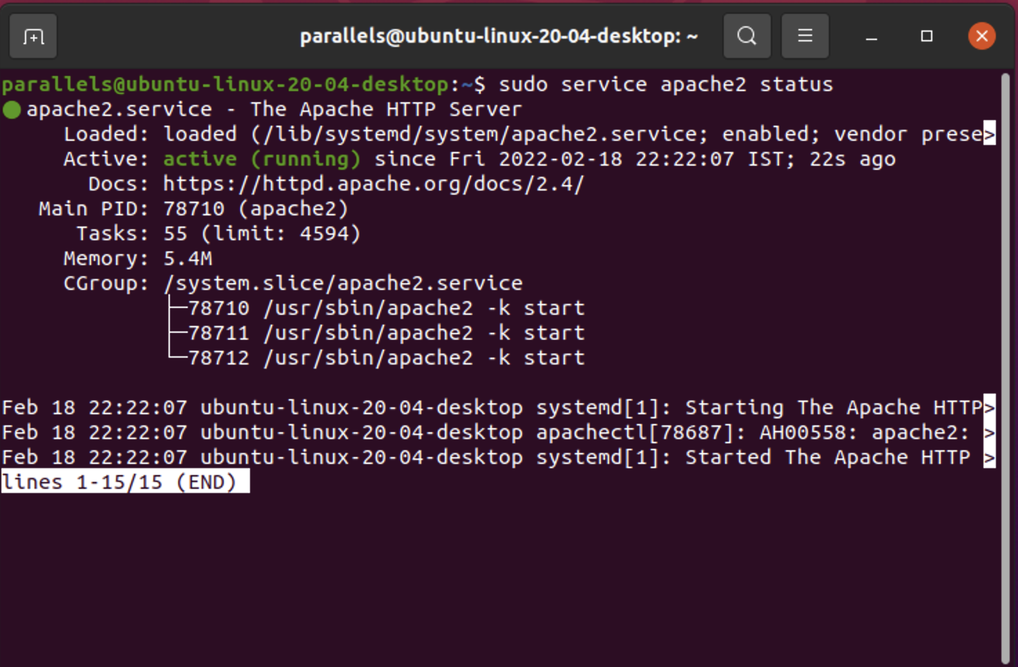

In Browser: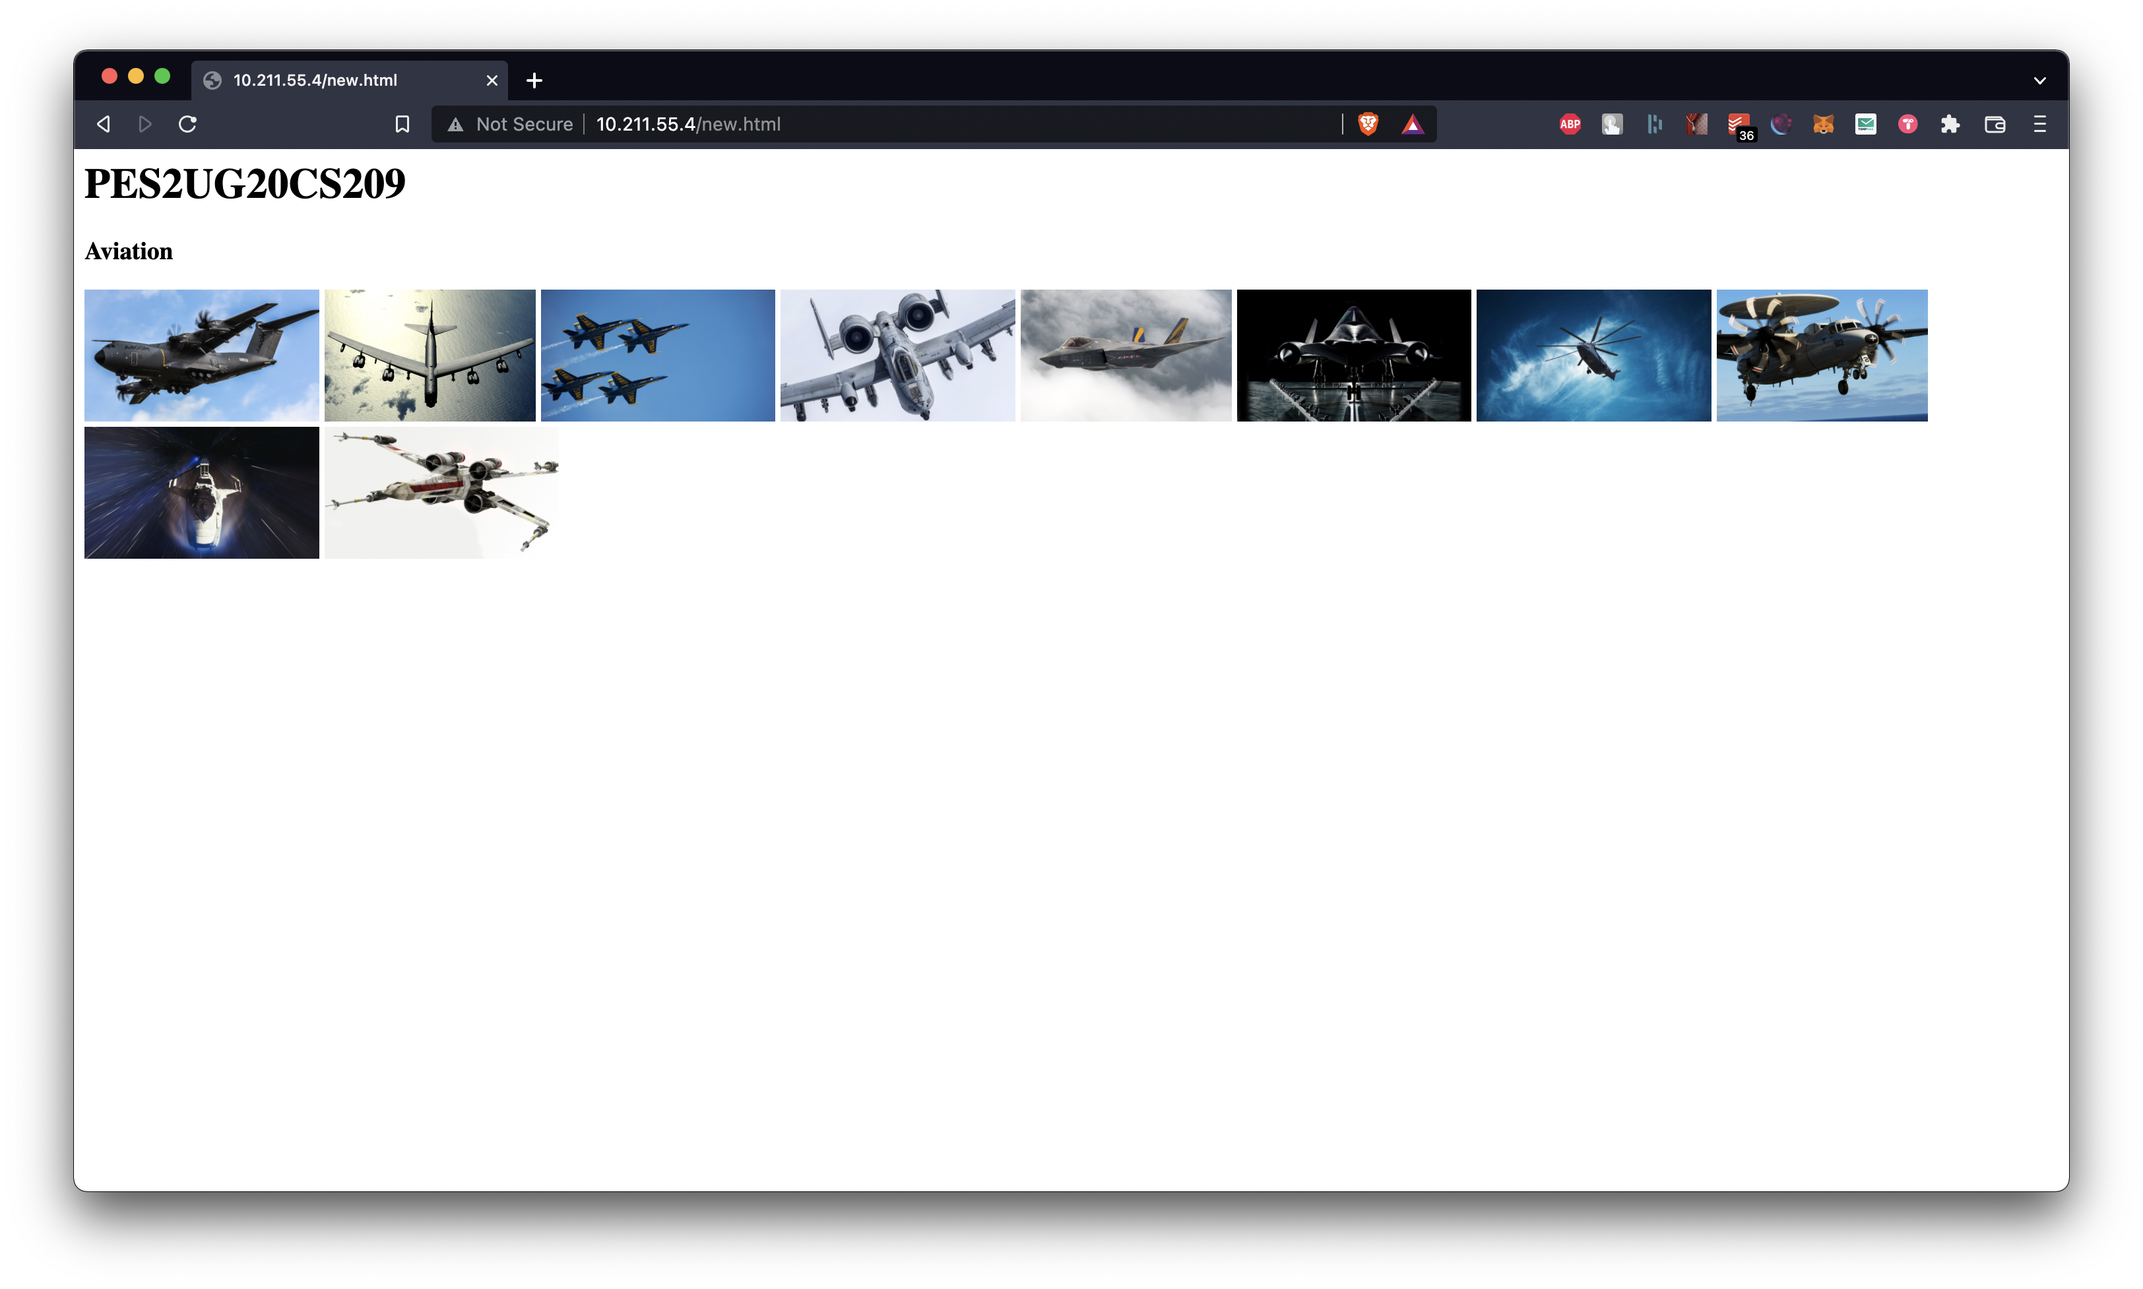

## Observation (Wireshark Capture and Time taken to capture all 10 images)

Non Persistent Connection:

Time Taken: 0.098332-0.005746=0.092586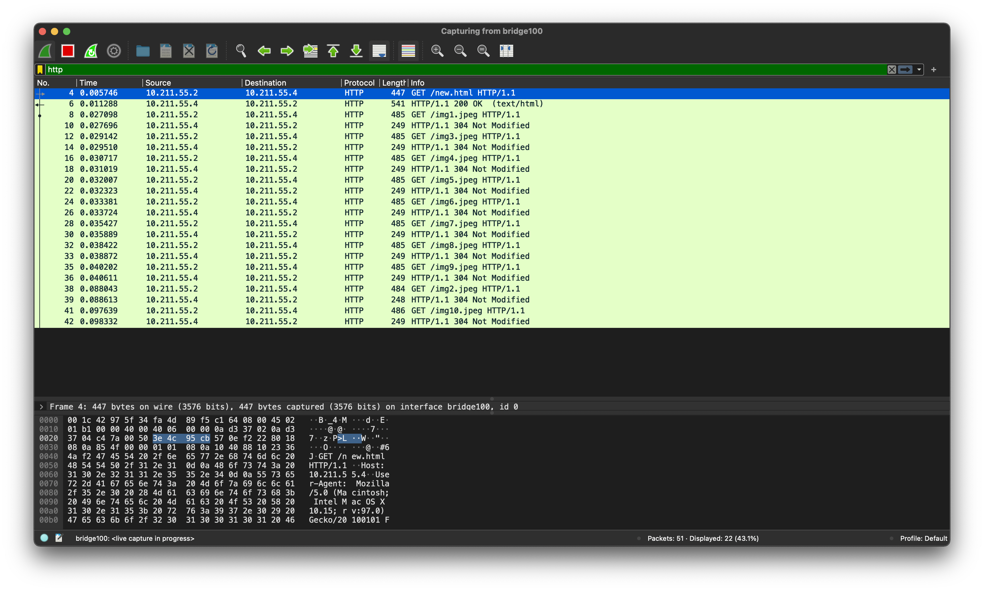

2 Persistent Connection:

Time Taken: 0.027189-0.003226=0.023963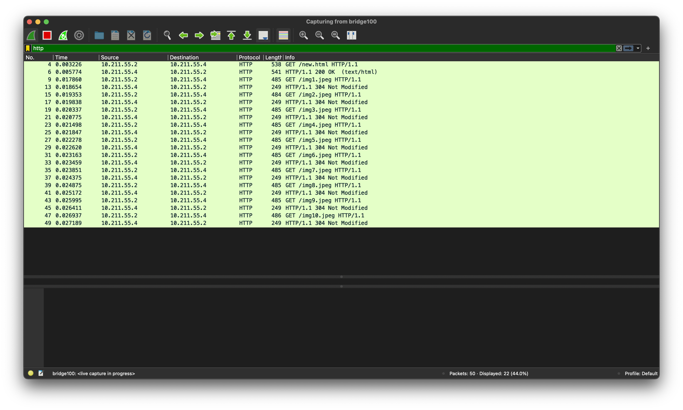

4 Persistent Connection:

Time Taken: 0.035509-0.003771=0.031738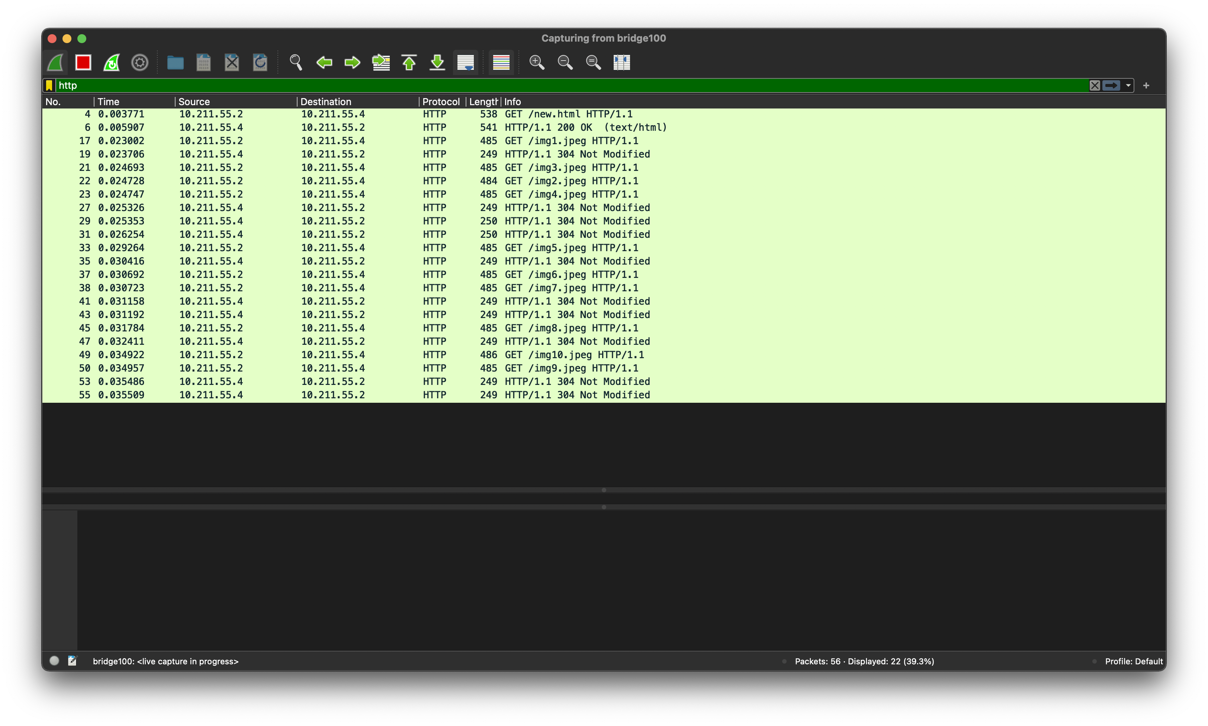

6 Persistent Connection:

Time Taken:0.037153-0.004797=0.032356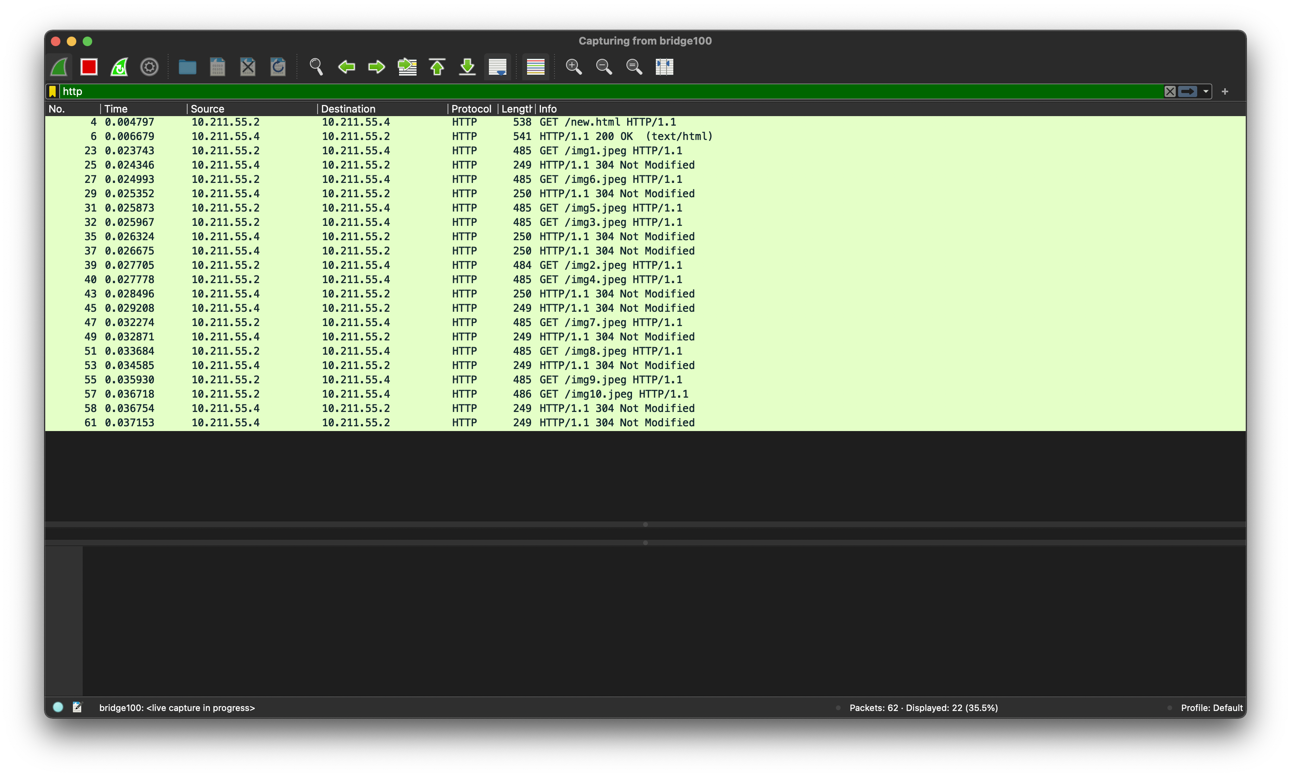

8 Persistent Connection:

Time Taken: 0.059615-0.002923=0.056692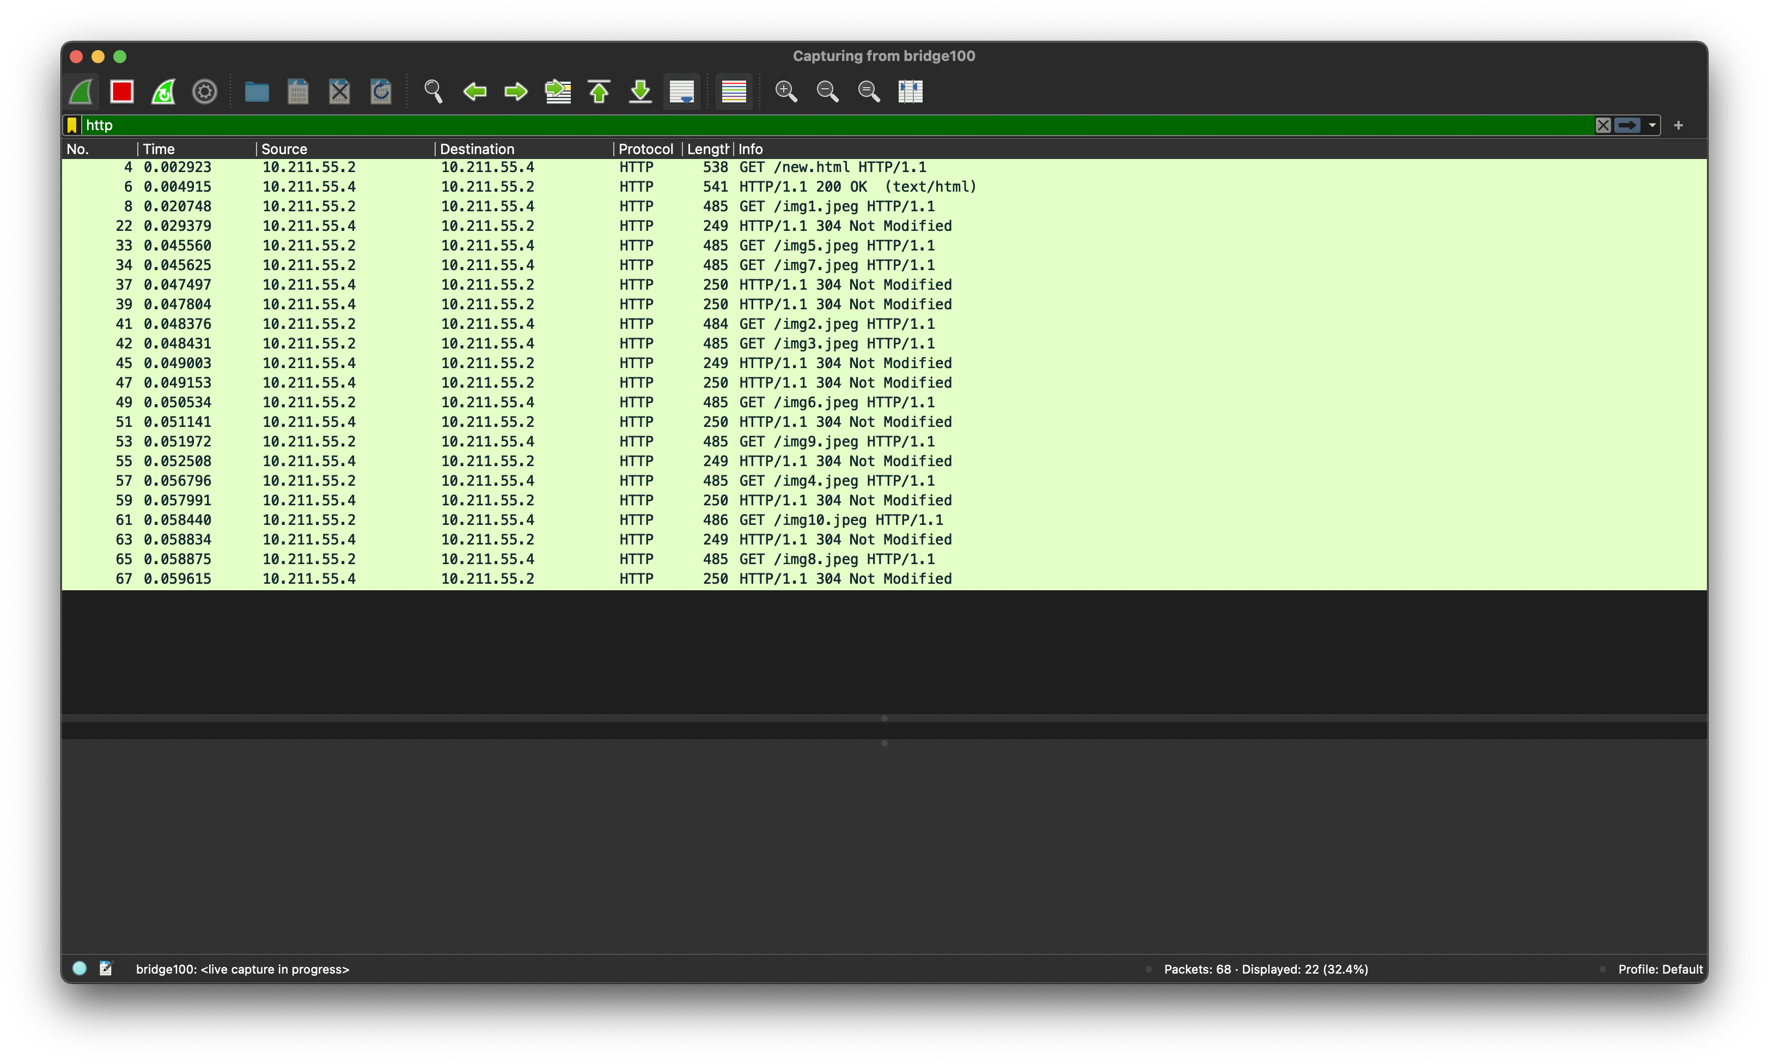

10 Persistent Connection:

Time Taken: 0.054985-0.003309=0.051676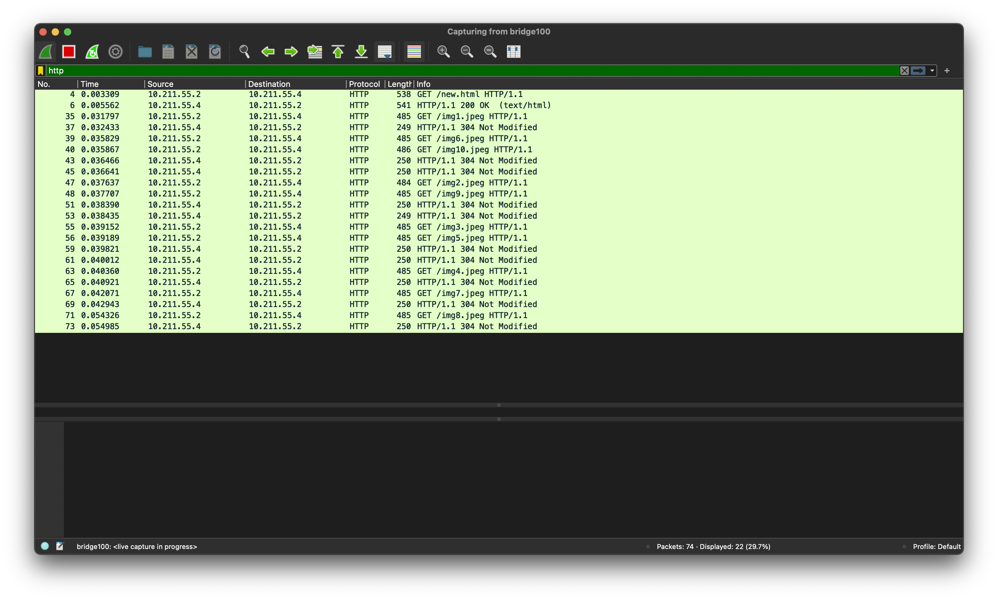

Understanding Working of HTTP Headers

## Objective:

Understand working of HTTP headers: Conditional Get: If-Modified-Since HTTP Cookies: Cookie and Set-Cookie Authentication: Auth-Basic Design a web page that has one embedded page (e.g. image) and sets a cookie and enables authentication. You are required to configure the web server (e.g. apache) with authentication mechanism. Show the behavior of conditional get when embedded objects is modified and when it is not (you can just change the create date of the embedded object). Decode the Basic-Auth header using Base64 mechanism as per the password setup.

## Observation:

Show the behavior of browser when is cookie is set and when cookie is removed.

## Task 1: Password Authentication

Authentication: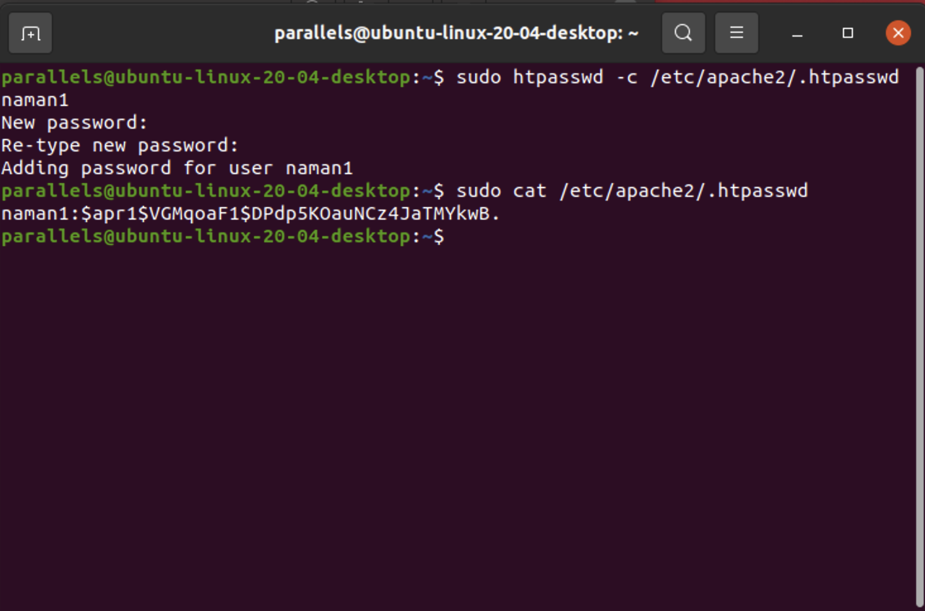

Wireshark:

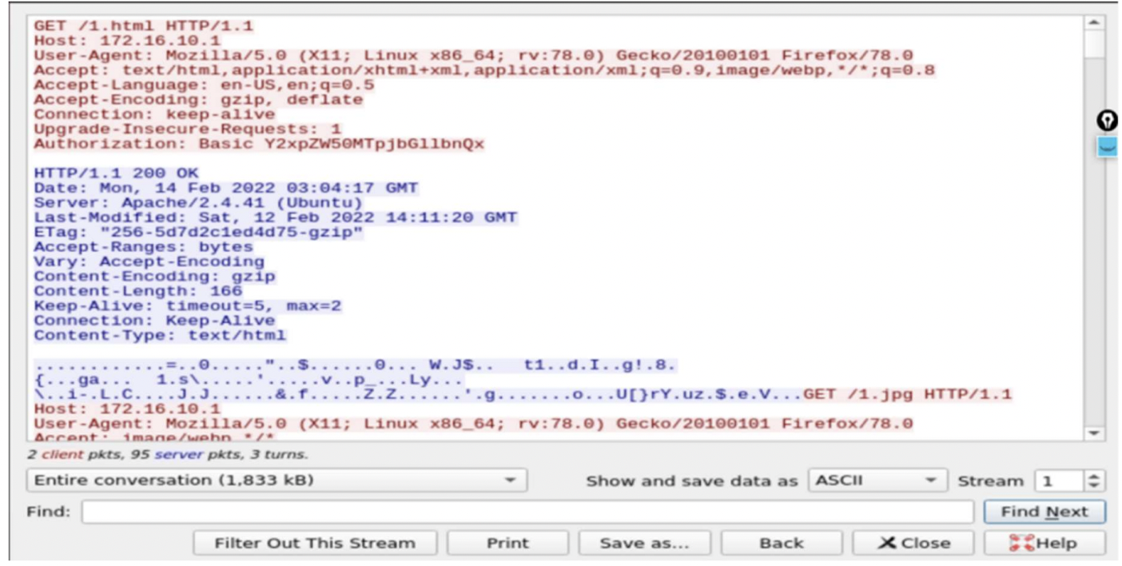

## Task 2: Cookie Setting

File Config: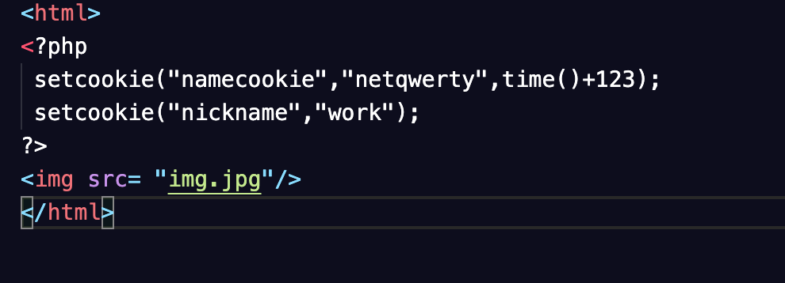

Wireshark:

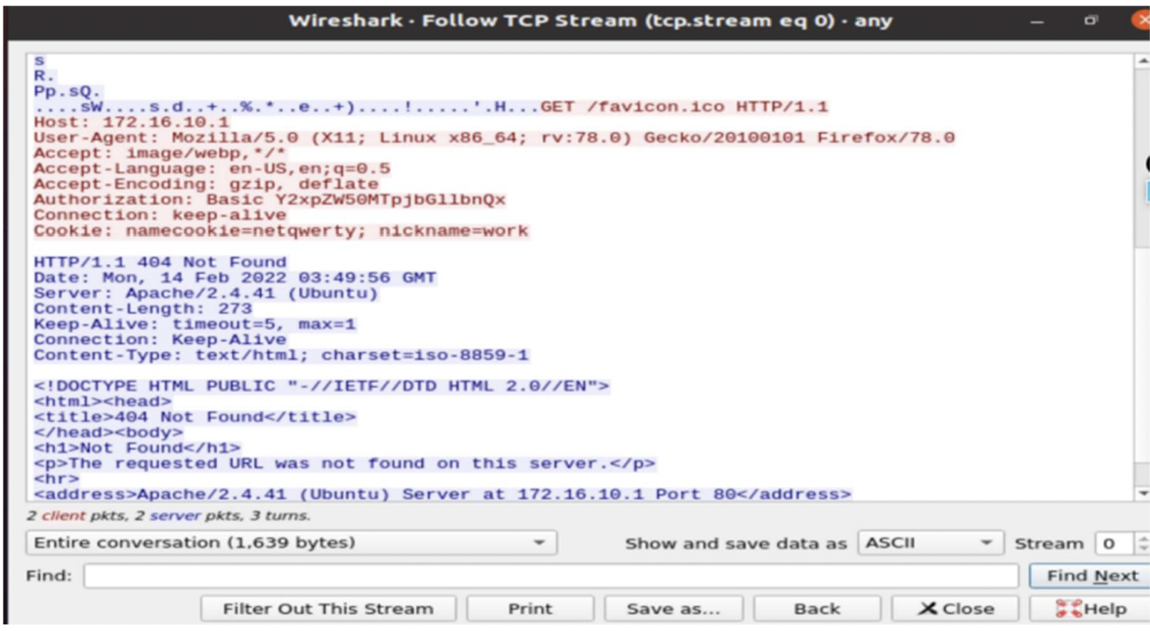

First GET request:

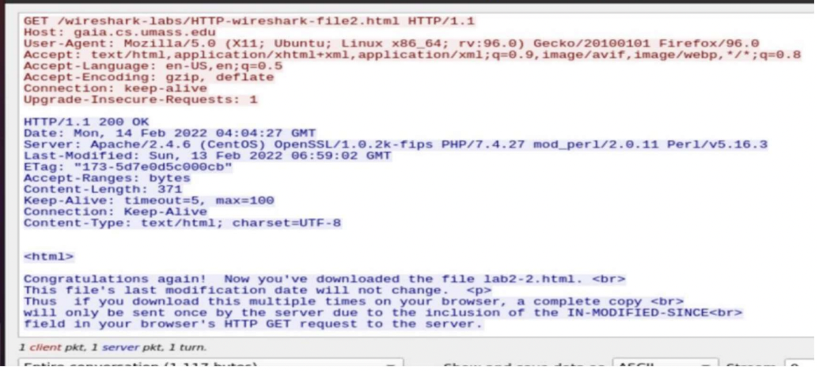

Second GET request:

